**EE 316 - Electronic Design Project**

Project: P4

**DC Motor Speed Controller**

**Final Project Report**

10 JUNE 2022

**Objective**

Our aim in the DC motor speed control project is to set the speed of a DC motor between determined voltage values by creating a closed system and to show the rotational speed of the motor between these voltage values. With the pulse width method we will use in the project, we will transmit the power to the DC motor with square waves. Thus, we can operate the system stably with less energy and higher efficiency compared to the methods applied in other DC motor speed control projects.

Our aim is to control the DC motor by keeping it at 3 different speeds, RPM. Therefore, we will need an error signal to control this closed system. In short, we will be able to provide high power control with a low reference signal. In the last stage of the project, the rotation speed of the BCD type dc motor will be determined with a digital circuit and displayed with a digital display.

**Group Members**

**Group Members**

**Common efforts:** DC Motor Speed Control

**Emirhan Yorulmaz - 260206058**

**Ferhat Böcek - 260206070**

**Hüseyin Kaan Türk - 240206031**

**Revision History**

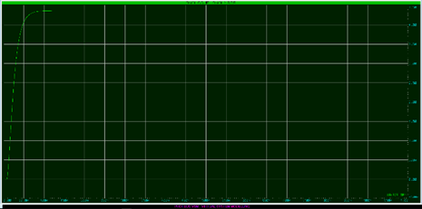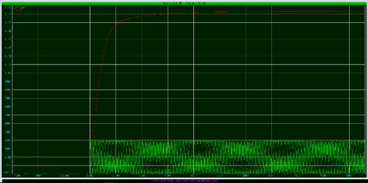

**Figure 1. Two different outputs for different converter methods.**

As stated in the previous report, various conversion methods are available when moving from frequency values to voltage values. DC voltage values obtained from MMV circuits created with LM2917 and Timer555 are available above. In the figure above, the DC voltage values obtained with the LM2917 and the MMV circuit in the right image are observed. In the continuation of the project, the MMV circuit was preferred and the other stages were arranged on this output.

There are two main factors in choosing this circuit. One of these factors is the easier implementation of ripple control in the MMV circuit. Another factor is related to reaction time. The response time of the DC voltage was obtained later with the LM2917. Quick response is an important factor in engine control. For these reasons, MMV was preferred and other stages were started in the project.

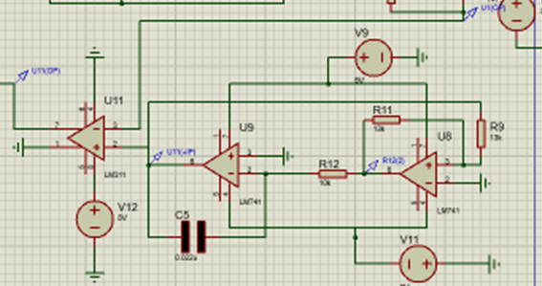

**Figure 2. PWM Circuit schematic**

In the figure we see the PWM circuit diagram. The same op-amp element was preferred in the Schmitt trigger integrator and comparator stages. This caused a big mistake. For the comparator stage at the end of the circuit, LM311 with this feature was preferred and continued.

**1. Introduction**

In this section, the methods used from the beginning to the end of the project and the solutions to the problems encountered are explained. Technical details were avoided in the explanations and the whole process was mentioned in general terms. In our dc motor speed controller project, which is tried to be built as a closed system, it is aimed to explain the steps in a sequential manner with all the processes from the input to the output of a system.

**1. Phototransistor Output and MMV**

As we mentioned in the previous stages, a disc with 16 holes is attached to the top of our engine. Our goal at this stage of the project is to obtain an input signal with the help of the holes on the disc and our phototransistor. When the photodiode emits light through the holes of the disk to the phototransistor, a signal is generated. The peak to peak value of this signal is quite small. The purpose of the amplifier used in the project here is to increase the peak to peak value of the weak signal coming from the phototransistor. Using a simple comparator circuit, we both increased our signal between -0.2V/0.2V, which we assumed came from the phototransistor, and we obtained 1.5-4V peak values. As mentioned earlier, the main purpose of an MMV is to generate pulse signals with a set Tone time. The output value of the MMV will give DC voltages proportional to the desired frequencies. Here we should observe an increasing DC voltage value as we increase the frequency over time.

At this stage of the project, we encountered two main problems.One of them was the small signal from the phototransistor. We solved this problem with the help of an op-amp and got a square wave in the range of 1.5V-4V. The other problem was the one from MMV. This problem was fluctuations in DC voltage. Obtaining a proper DC voltage was an important step for the continuation of the project. We should have kept the response time short and avoided fluctuations. We solved these problems by passing our output value through RC filters.

**1.1 Amplifier and Differentiator Circuit**

The voltage values taken from the RC filter will correspond to values between 1200-2000-3000 rpm. These voltage values will need to be increased as the amplitude levels are very low. The amplitudes of 3 different signals representing 3 different speeds will be transmitted to the differential circuit after being amplified in the amplifier circuit. An error signal will be created by taking the difference between the voltage value given from the potentiometer and this amplified signal and will be used in the PWM stage. However, the DC value from the filter is in the lower voltage range than the desired value. Therefore, first the voltage is amplified by an op-amp circuit, then the signal from the potentiometer is inserted into the differential circuit and the error signal is generated, which will be the input signal of the PWM circuit.

**1.2 Pulse Width Modulation**

PWM is a method that we will use to control the speed of the dc motor. We will provide the speed control of the motor by generating square waves of different frequencies. By changing the T(on) times or duty turns of the square waves, we will control the power transmitted to the motor. Since the rotation speed of the motor depends on the time the square waves are active, we will need to increase the Ton time for the motor to accelerate. Because motor rotation speed is proportional to duty cycles. One of our primary purposes is to generate the input signal for the pwm circuit. So we need to be able to get the difference between the potentiometer and motor voltages. The voltage value obtained as a result of this difference will be the required signal for the input of our pwm circuit. In short, in order to control one signal, we will take the duty cycle and voltage of another signal as a reference. There are multiple ways to build a PWM circuit. 555 timer or comparator circuits may be preferred. We preferred to use comparator circuits in order to provide stable voltage control and to save power by consuming less energy.

**1.3 IC Driver**

We need an IC driver circuit to control the rpm of the dc motor in our project and to ensure that it rotates at a constant rpm. For this reason, we want the motor to rotate more efficiently by providing a stable rotation speed and saving energy. With the motor driver circuit, besides controlling the rotation speed of the motor, it will also be possible to adjust the acceleration and deceleration times. Thus, we will control the rotation speed, efficiency, consumed power and torque of the dc motor that we will control with the pwm method.

**1.4 BCD Counter and Display**

In the first part of the BCD circuit, a 555 timer is used to obtain a square wave with a period of 750ms. The rotation of the motor is 1200 rpm which corresponds to 20 turns per second. 1 tour takes nearly 50ms. If there were 1 hole on the disk fixed to the motor, a square wave with a period of 100ms can be obtained. But the motor disc in this project has 16 holes. When the light is emitted from the diode, it passes through one hole on the disc and activates the phototransistor, which generates one pulse. That's why we have to count the rotation of the 375ms motor from 50ms /16 because each 16 pulse turn corresponds to 1 turn of disc. This is why we obtain a pulse of 750 ms. The disable input of the 4553 IC is connected to the inverse (by not gate) of the wave that is generated by the 555 timer. By this NOT gate, 4553 counts during 375 ms where the square wave is 0V, by this way it holds the counted value during 375 ms where square wave is 5V. In the Counter and Display section, the upcoming signal is from the Adder and Comparator section. The pulses are used like clocks and it is counted as counterparts. For 3 digits, CD4553 is used. The integration counts of the upcoming clock and the output of that is binary coded decimal, which means BCD. In the display section, CD4511 is used for converting the BCD into 7-Segment display code. 7-Segment display is basically 7 leds to show the one digit. For a clear display, the counter must be resetted some interval. The resetting signal is produced from a timer which is 555. The timer produces a square signal, and the frequency and duty cycle are related with the resistor and capacitor values. We need 375ms high state and %50 duty cycle square signal to show 3-digit RPM with respect to the explanation above. With setting resistor and capacitor values. the signal is arranged to the desired values. This counter is sensitive to the negative edge. The latch enables the leg, providing how long the counter will run. With the 375ms high signal we obtained with the timer, we can enable this counter(4553) to work with certain time cycles. When we complete this counting process, we can send a pulse signal to the display select leg with the timer. In this way, we observe the speed of the dc motor on the display. And right after this display process, we can reset the counter to make it ready for a new cycle.

**2. Technical Description**

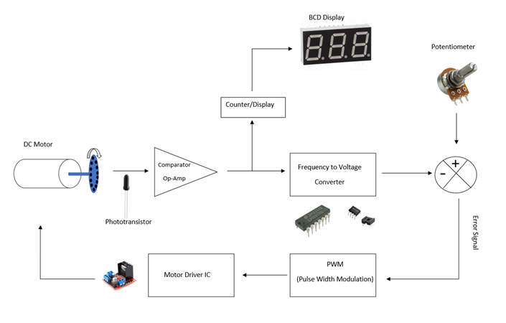

**Figure 3. Block diagram of the DC Motor Speed Controller**

Above is a block diagram of the entire project. The generated closed loop and the signals obtained at each step can be interpreted from the diagram.In the first stage, it creates a signal via the phototransistor with the rotation of the 16-hole disc connected to the motor end. This signal is converted to a square wave, which will be the input of the BCD counter and the MMV circuit.

Subsequently, the signal has reached the stage where it will be converted from frequency to voltage. At this stage, the DC voltage equivalent of the rotational speed of the motor is generated. There are many conversion methods at this stage. As explained before, a monostable multivibrator was preferred in the project.

Then, an error signal is generated by controlling the obtained DC voltage with a potentiometer and this error signal will be effective in the speed control of the motor. This error signal, which is the input of the PWM circuit, will be output from the PWM circuit as a square wave whose active time is adjusted. This signal, which will provide power to the DC motor according to the activity time, will save power and also play a role in speed control effectively.

Finally, the square wave driver created in the PWM circuit will be transmitted to the IC. The driver circuit, whose working principle has been explained before, will switch the motor according to the high and low values ​​of the square wave in logic 0 and logic 1.

**2.1 MMV(Monostable Multivibrator)**

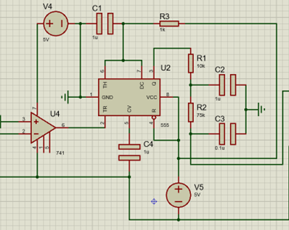

**Figure 4. MMV Schematic**

As we mentioned before, a signal like a pulse signal in the 1.5-4V range was generated with the LM741 component following the signal consisting of a phototransistor. This signal must be converted to DC voltage with the MMV circuit whose schematic is given above. This is necessary because in the following sections, an error signal will be obtained by comparing the DC voltage value with the DC voltage value given from the potentiometer. Therefore, the incoming pulse signal is converted to DC voltage by the MMV circuit. The MMV is triggered by another signal to produce pulses with desired Tonal values. We can use the resistance and capacitance values used in the circuit to find the tone duration. We can use the following formula to reach this Tone value in our circuit.

Our R3 value is equal to 1kohm and C1 value is 1 microfarad. With these values we get 1ms Ton time. Afterwards, we can reach our DC signal by applying a cascade filter process to this pulse signal. Below is a general formula for second-order low-pass filters.

When we calculate this with the values ​​in our own circuit, a cascade filter with a cutoff frequency of 18.38 Hz was made. As a result of this filter, DC voltage directly proportional to frequency was obtained.

**Figure 5. Output MMV (green one) and after filtering(red one)**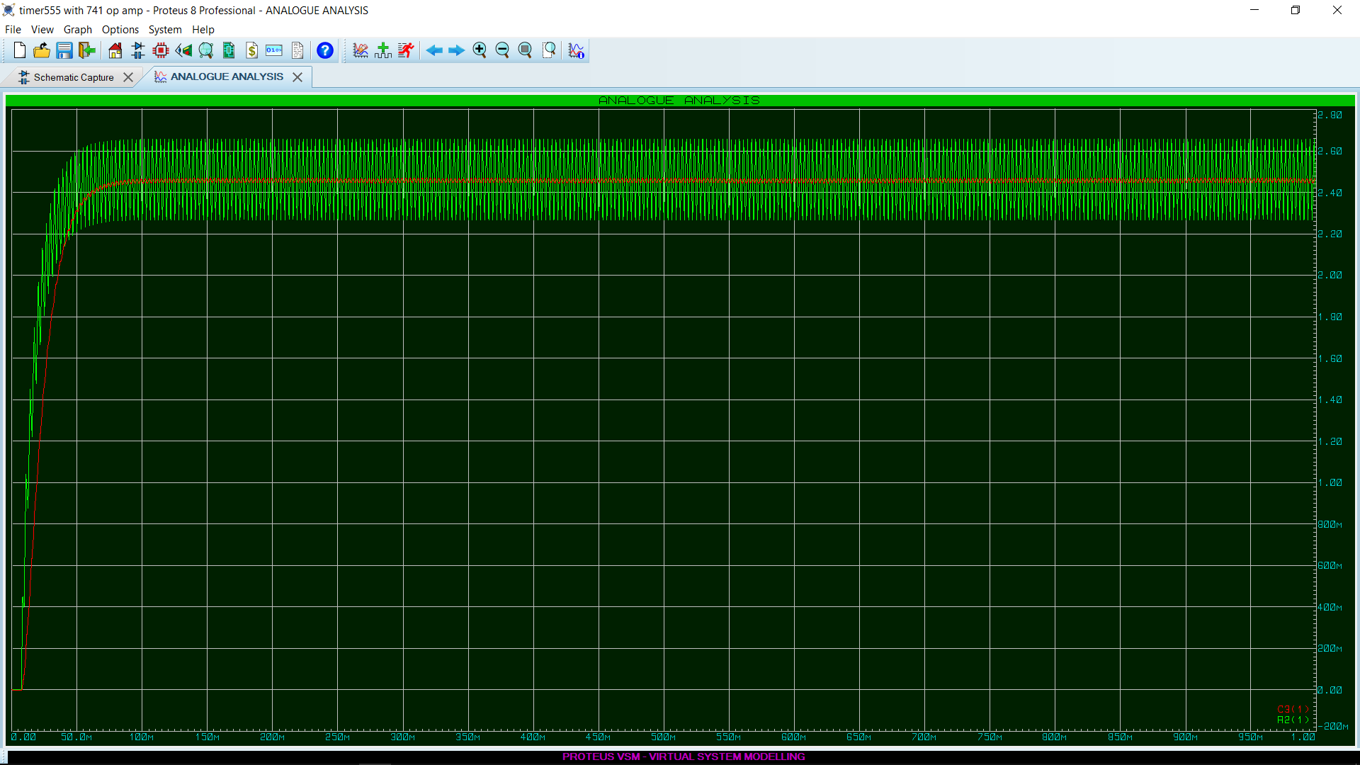

**2.2 Pulse Width Modulation (PWM) and Error Signal**

The input voltage of the Pwm circuit was obtained by taking the difference of the motor and potentiometer voltages. In fact, we can call the frequency to the voltage converter to output the voltage value of the motor. Before expressing the working principle of the PWM circuit, briefly repeating the process up to this stage will make our project more understandable. First of all, the voltage value we want the motor to rotate will be the potentiometer. We will get an error signal by taking the pot - motor difference. If the error signal is positive, the dc motor needs to be accelerated. So if the pot voltage is greater than the voltage from the motor, it means speed up. In this case, the duty cycle should be above 50%. If the pot - motor difference is negative, it means slow the motor down.

If we want the duty cycle to increase where the voltage is high, that is, if we want the duty cycle to increase where the error signal is large, we need to give the triangle wave to the + input of the LM331 op amp inputs and the error signal to the - input. The speed that the motor should follow depends on the error signal. We used 3 different signals obtained after the rotation of the DC motor at 3 different rpm by separating them with a triple switch, but normally we were not supposed to adjust these values. The phototransistor had to detect the signals. That is, if I set the required voltage for the motor to rotate at 3000 rpm while the motor is rotating at 1200 rpm, the error signal will be positive. If the Error signal is positive, the duty cycle of the Pwm output will increase and the motor will accelerate. Here we are just changing the pot value. As the motor will rotate faster, the phototransistor will perceive the frequency higher. So we will try to create a feedback system. In short, if we want to speed up the dc motor, we will increase the duty cycle.

Signals representing 3 different RPM speeds (1200rpm, 2000rpm, 3000rpm) reach the minus (-) input of the LM311 op amp, which is the last stage of the pwm circuit, by taking their difference with the potentiometer voltage. In the pwm circuit, the schmitt trigger circuit will produce a square wave between 0-5v, and then in the integrator circuit, after the square wave is converted to a triangle wave, the difference will be compared with the dc signal coming from the differential circuit. Here we see the pwm outputs of signals representing 3 different speeds.

**Figure 6. 320 Hz - 1200 RPM - PWM Output** 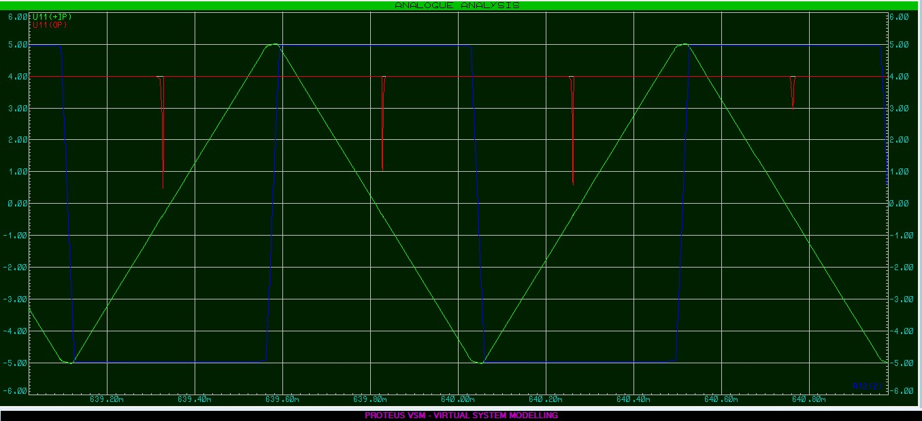

**Figure 7. 533 Hz - 2000 RPM - PWM Output**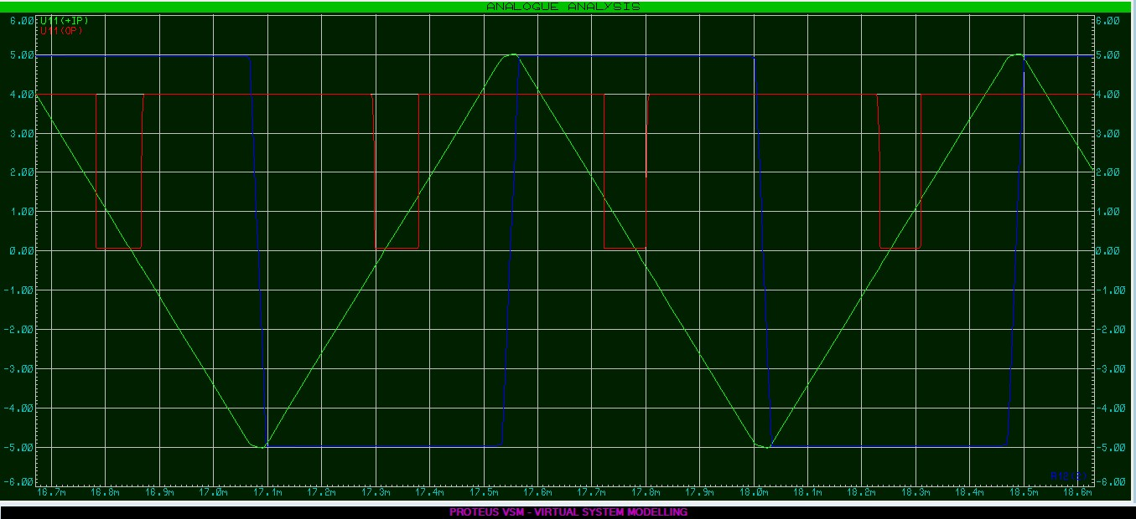

**Figure 8. 800 Hz - 3000 RPM - PWM Output** 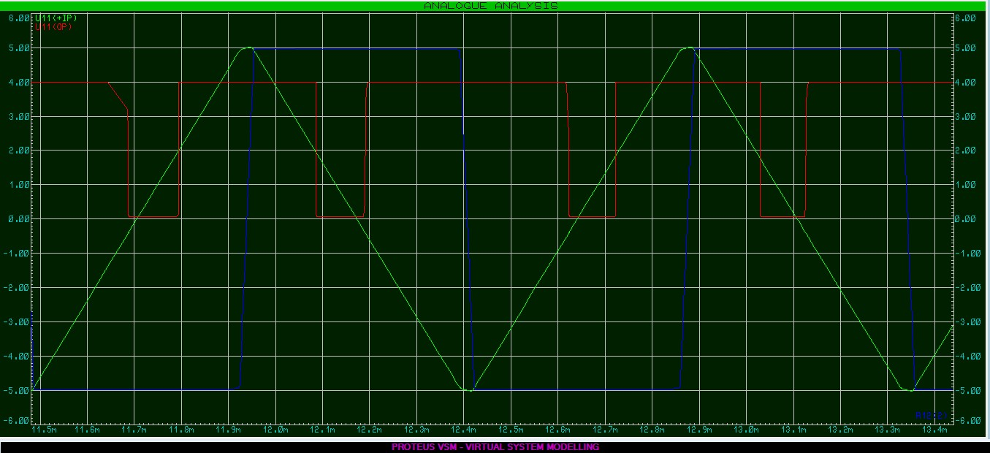

Schmitt Voltage : Blue Signal

Integrator Voltage : Green Signal

PWM Voltage : Red Signal

**2.3 IC Driver**

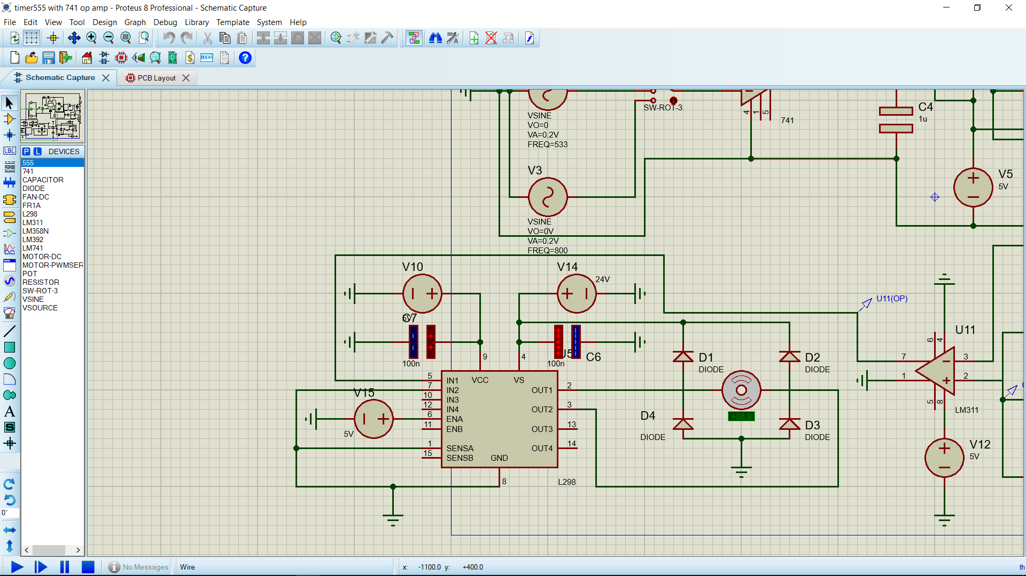

**Figure 9: IC driver circuit schematic**

Above we observe the driver circuit. The input of the driver circuit will be a square wave obtained from PWM. When IN1 equals 0V, the driver turns off the motor, otherwise it turns on. With this working principle, power savings will be achieved and this is one of the main reasons for choosing PWM in this project.DC motors have some back electromotive force. This force can damage the drive when the motor starts. In order to avoid this damage, protection is provided to the circuit with diodes.

**2.4 BCD Counter and Display**

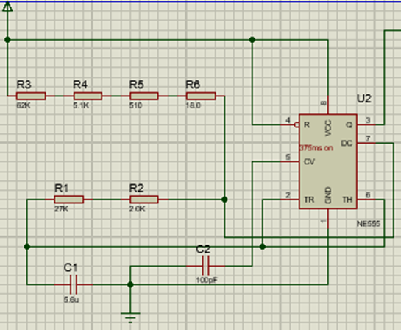

**Figure 10: Separate Timer Circuit**

This Project separated into 2 parts as Display, IC; then joined together to obtain the main Project. To make the display part separately , there should be an incoming clock signal from the IC part to make displayments clearly. To make this signal , first a timer circuit(NE555) built with calculated resistor values). This timer circuit derives a 375 ms up signal and is used as a clock. Then secondly, an input signal (IC’s output signal) given with a signal generator to obtain desired display results. Timer circuit gives us the correct clock cycle and the display circuit gives us the desired displays. To make this display smoother , leech enable and reset buttons should be logic gated, with the help of this logic Gates there is no unnecessary counting in display LEDs. Display circuit built with 3 ICs. These are a counter 4511, a decoder 4553 and the 7segment 4 mux cathode display. This 4 mux model of LED's is converted into a 3 digit(mux) model of leds via the component creator of proteus.

**3. Test Results**

**3.1 MMV Test Results**

In the table below, the output values ​​of the MMV circuit in different states are observed.In this phase, where we converted the pulse signals into DC voltage, DC voltages corresponding to 2.45V, 2.90V, 4.30V values ​​were obtained for 320-533-800Hz values. Since these values ​​are fractional and give close outputs for 320Hz and 533Hz, the voltage values ​​have been increased to obtain more noticeable values ​​and continued with 2.70V-3.20V-4.80V values.

| **Design Target** | **Measured Value** |
| --- | --- |
| **Input Voltage** | **1.5-4V** |
| **Output Voltage of MMV** | **0-5V** |
| **Output Voltage of Filter** | **2.7-4.8V** |
| **Duty Cycle** | **48-100%** |
| **Input Frequency** | **320-800 Hz** |

**Table 1: MMV test results**

**3.2 PWM Test Results**

Since we needed to fix the speed of the DC motor between 1200 rpm and 3000 rpm, we had to limit it by adding an external resistor to the potentiometer. At this stage, we set up a voltage divider circuit and limited the potentiometer to 12.8k and 0.53k resistance values. Thus, we reached the voltage values we needed to achieve 3 different rpm speeds corresponding to 320Hz, 533 Hz and 800 Hz frequencies. When we take the difference between the potentiometer voltage and the dc motor voltage, we aim to see the minimum 2.70V and the maximum 4.80V output. Thus, we will ensure that the Pot rotates at the highest and lowest resistance values of the dc motor at a minimum of 1200 rpm and a maximum of 3000rpm.

| **Design Target** | **Measured Value** |
| --- | --- |
| **Error Voltage** | **-3.5 to +2** |
| **Triangular Wave** | **-5V to 5V** |
| **Control Voltage** | **-5V to 5V** |
| **PWM Duty Cycle** | **40-100%** |
| **Frequency of PWM** | **1.07 KHz approximately** |

**Table 2: PWM test results**

**3.3 BCD Counter Test Results**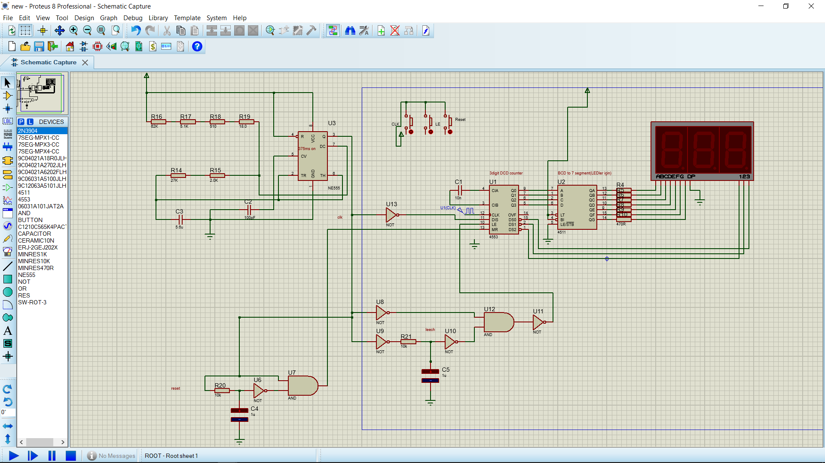

**Figure 11 : Circuit schematic of BCD counter and Display**

| **Design Target** | **Values** |
| --- | --- |
| **Display** | 1180-2960 rpm |
| **BCD Clock input frequency** | 320-800 Hz |
| **Timer pulse oscillation frequency** | 747ms |
| **BCD MR input frequency** | 747ms |
| **BCD LE input frequency** | 747ms |

**Table 3 : BCD test results**

This circuit contains a 3-digit display, so motor rpm should be divided by 10. The Circuit motor rotates between 1200-3000 rpm, so the display should be 120-300 respectively. This means the motor takes 20-50 cycles per second. Therefore, the BCD counter should count to 375ms. The timer circuit (left top in the figure) is set to 747ms for this purpose. BCD MR frequency and BCD LE frequency have the same 747ms signal. BCD input clock frequency is the signal that is produced in the Adder Comparator part/phototransistor. Generally, we obtained values that is so close to desired values. The difference can be neglected.

**4. Conclusion**

The purpose of the analog part of this project is to control the speed of a DC motor between the desired rpm values using the pulse width modulation method. The purpose of the digital part of the project is to show this obtained rotational speed.

The first step of the project is to obtain an electrical signal from the rotating motor, on which a 16-hole disc is attached. In this process, using a pair of led and optical sensors, a pulse signal should be obtained when light passes through the hole in this disc. Since this process cannot be processed in the simulation, we obtain a sinusoidal signal output by making use of the datasheet data. Then the sinusoidal wave must be converted to a square wave and supplied to the circuit. This input signal should be converted into a pulse signal with the monostable multivibrator circuit we mentioned in the technical explanations. This generated pulse signal must be converted to a DC voltage equivalent using RC filters. In order to obtain a suitable voltage, two filtering processes were applied as cascade and a DC voltage was obtained. Thus, we obtained a smooth dc voltage signal by filtering the ripples in the output dc signal with 2 RC circuits installed at the monostable multivibrator output. This is necessary because when generating the error signal, an error signal is provided by taking the voltage from the potentiometer and the DC voltage difference generated. The error signal will be used to determine the rotational speed of the dc motor, to decrease or increase its speed, and to ensure that it rotates steadily at certain highest and lowest speeds. For this reason, the rotation speed of the motor will be adjusted according to whether the error signal is positive or negative. In order to obtain the error signal, the difference between the potentiometer voltage and the motor voltage is taken in a differential circuit.

By using the DC signal from the differential circuit at the last stage of the PWM circuit, a square wave will be created with the desired duty cycles. The general purpose of the PWM circuit is to provide power control by controlling the duty cycles of square waves. Since the Tone duration in the duty cycles will control the acceleration and deceleration conditions of the motor, our aim is to produce a square wave pwm output by comparing the Tone duration with the error signal and the triangle wave signal that we will produce at the last stage of the PWM circuit. The comparator circuit generates +V or -V square wave pwm output by comparing the error voltage with the voltage levels of the triangle wave.

The signal obtained from the PWM output will then be used as the input signal of the IC driver circuit. The given voltage level of 0 and higher will control the running and non-starting state of the motor. Thus, a power-saving DC motor speed control process that we mentioned at the beginning will be completed. However, in our simulation, the engine will never stop completely due to the engine rotation speed, which will be kept between 1200-3000 rpm.

Second part of this project is Binary Decimal Counting and displaying the motor speed. MMV generates a square wave signal and this signal sent to BCD counter(4553). Then BCD counter starts counting and this counter data gives directly to decoder(4511). After that decoder converts this BCD data to 7segment display data. In general, the NE555 timer circuit generates a signal with a period of 750ms. The inverse of this signal(obtained by a NOT gate) is connected to reset input of 4553(MR). This 750 ms signal includes 375ms high input and 375ms low input, so counter counts during 375ms and the other 375ms effects counter to hold its value. Master Reset of 4553(MR) becomes 1 at high inputs, and will reset at 376th ms(low part). In 375ms low input of timer signal, LE becomes 0 and the value is taken as instant. This prevents counter to count every motor cycle. Counter directly displays the total motor cycle count.

**5. Component List**

| **Component Name** | **Package Number** | **Manufacturer** | **Supplier** |
| --- | --- | --- | --- |
| **Timer** | **NE555** | **Texas Instrument** | **www.direnc.net** |
| **Not Gate** | **74LS04** | **Fairchild** | **www.direnc.net** |
| **Opamp** | **LM741** | **Texas Instrument** | **www.direnc.net** |
| **Opamp** | **LM311** | **Texas Instrument** | **www.direnc.net** |
| **Timer** | **NE555** | **Texas Instrument** | **www.direnc.net** |
| **IC Drıver** | **L298N** | **STMıcroelectronics** | **www.direnc.net** |
| **10K Potentiometer** | **Potentiometer** | **Spike** | **www.direnc.net** |

**References**

[1] <https://ctools.ece.utah.edu/ECE1250/ECE1250_Lab04_PWM_Explain.pdf>

[2] <https://www.circuitstoday.com/555-timer-as-monostable-multivibrator>

[3] <https://www.analogictips.com/pulse-width-modulation-pwm/>

[4] <https://www.st.com/en/motor-drivers/l298.html>

[5] <https://www.electronics-tutorials.ws/filter/filter_2.html>

[6] <https://www.build-electronic-circuits.com/h-bridge/>

[7] <https://www.build-electronic-circuits.com/4000-series-integrated-circuits/ic-4511/>